
In the spring of 1989, the Boston School Committee declared that the Patrick O’Hearn Elementary School would become an inclusive school beginning that fall. Since it’s commitment to inclusionary practices almost two decades ago, the O’Hearn has become a model of innovation, collaboration and high expectations for students with disabilities. The O’Hearn currently serves an ethnically, linguistically and racially diverse group of students in early childhood through grade five. Within the student population, approximately 33 percent of the students have a disability, many of which are labeled significant. Due to the hard work of its faculty and administration, the O’Hearn is a high performing school within Boston. Student attendance approaches 95 percent with relatively few discipline referrals.
Integral to the school’s success is the use of accommodations. Accommodations enable inclusion and, “for most children with disabilities, integration into regular classes with appropriate accommodations and support should be the norm” (Hehir, 2005, p. 69). Dr. Bill Henderson, principal of the O’Hearn, writes, “There can be no pretense of teaching all students in inclusive classrooms by using the exact same curriculum materials and instructional strategies. This “one-way fits all” would not be good pedagogy even in so-called homogeneous classes. At the O’Hearn where there are students working at, above, slightly below and well below grade level in every room, a single approach was never an option.” (Henderson, 2003, 4) A text-reader is just one of the accommodations the O’Hearn uses with their students on a daily basis in order “to minimize the impact of disability and maximize the opportunities for children with disabilities to participate in general education in their natural community” (Hehir, 2005, p. 49).

The Patrick O’Hearn Elementary School
Dorchester, MA

Text Reader Overview
A text-reader is a software program that removes the decoding barrier by allowing students to listen to digital text. Teachers are able to scan the traditional text into the computer whereby the student is then able to track the text with a highlighter as the text reader simultaneously decodes and reads the content to the student. Most text readers include a word prediction function, which reads to a student what they are typing on the computer. Based on frequency, it predicts the word a student is trying to spell and allows the student to choose from a list of likely choices. Additionally, text readers can function as a study skills aide. For example, teachers can post comprehension questions about a particular book on the computer. Students can then access this text and answer the questions online. The student’s answers can also be extracted from the book and pasted into an answer sheet for easy printing. This capability allows teachers and students to effortlessly document and share their work with other students, teachers and parents.

Contents
Background 1
Text Reader Overview 1
When to Select 2
Quantitative Impact 3
Qualitative Impact 3
Testimonial 3
Technical Implementation 4-5
Adaptive Implementation 5
Moving Forward 6
Visual of Text Reader 7
Contact 7
Sources 7

“Champions of inclusion CREATIVELY adapt and UTILIZE appropriate strategies and materials to help students with disabilities learn and succeed.”
-Dr. Bill Henderson

Introducing Text Readers in the Classroom
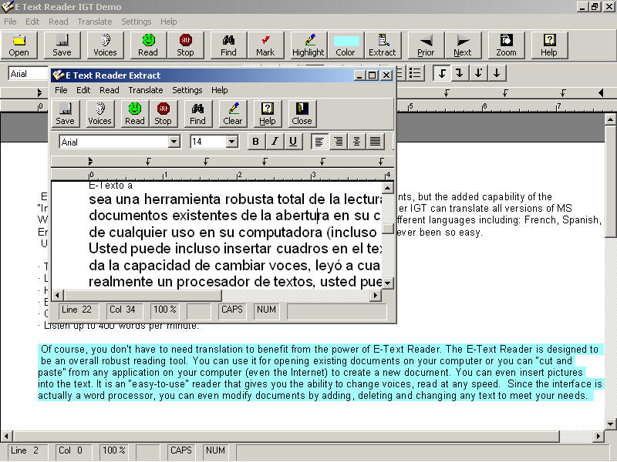
Text readers were originally designed for use by people with visual impairments who traditionally had a hard time accessing print. The accommodation was soon realized to be appropriate for students with learning disabilities, in particular dyslexia and dysgraphia. Students with dyslexia have a break down at the phonemic level, which limits their ability to decode words fluently (Shaywitz, 2004). While they are able to comprehend at a typical and sometimes advanced level, their struggle with decoding often limits their access to grade level curriculum. As such, text readers can help remove the decoding barrier of the reading process and enable students to read and comprehend more fluently. Additionally, the word prediction function helps students spell accurately and efficiently.
Students with dysgraphia struggle to produce legible print due to atypical neural connections. Regardless of their ability to read, people with dysgraphia often lack coordination and may find other fine motor tasks difficult. Basic spelling skills are also a problem. Given their challenges, the word prediction function on a text reader helps these students convey their thoughts in writing more efficiently. Furthermore, people have started to study text readers’ potential positive impact on other disabilities. They can help students with cognitive impairments access more books independently. Some nascent research has shown that text readers are effective for students with ADHD who struggle to maintain focus during longer tasks (Weinberger, 2008). Other studies have even begun to examine the potential benefit for students with autism. Aside from students with specific and identified disabilities, text readers can be an effective intervention for any struggling reader.
The decision to adopt Kurzweil as the text reader at the O’Hearn was based on a careful and thorough evaluation of student needs. The staff and administration recognized that many students struggled with reading as a direct result of vision issues, specific learning disabilities and language processing problems. Prior to implementing Kurzweil, many students accessed text through books on cassette but the school identified some flaws with this accommodation. First, Dr. Henderson reports that some students felt embarrassed about using the technology. Some of the older kids were comfortable with books on cassette while others were not. For others it was hard to identify specifically where students struggled. For example, students with processing issues who struggled to lift print off the page might also have had listening comprehension issues. However, it was hard to make this distinction using only books on cassette to support their reading. When Dr. Henderson and the staff became aware of Kurzweil’s text-to-voice functions as well as its ability to scan content and provide study skills, they were optimistic this could be an effective accommodation for certain students. Dr. Henderson stated that, “…it allowed kids to both see and hear the text. They were using their eyes and ears and accessing information in dual mode. I think any boost they can get the better. Since it was on the computer and because of the control [students] can get over changing and selecting [their] own voice style, changing and selecting [their] own voice speed, it was more attractive, sophisticated and cool. We found very little embarrassment or stigma about using the computer. The teachers found that other kids who did not have learning difficulties or disabilities were requesting, ‘Well can I read the book on the computer too?’”

“It allowed kids to both see and hear the text. They were using their eyes and ears and accessing information in dual mode. I think any boost they can get the better. We found very little embarrassment or stigma about using the computer. The teachers found that other kids who did not have learning difficulties or disabilities were requesting, ‘Well can I read the book on the computer?’”

When to Select a Text Reader Accommodation

The O’Hearn
Text Readers in the Classroom

Qualitatively, student work and efficiency greatly improved with the implementation of text readers in the classroom. Several articles of student work, with and without the accommodation, were collected and analyzed. A typical comparison in student product is demonstrated in Appendix B. A second grade student was asked to write three sentences about a book that he had read. In the first sample the student completed the task without Kurzweil and used only pen and paper to convey his thoughts. After laboring for 45 minutes to complete the assignment, the student was only able to produce three relatively illegible and incomplete sentences. When given a different but similar prompt and allowed to use the text reader, the child was able to write ten complete sentences within 15 minutes.

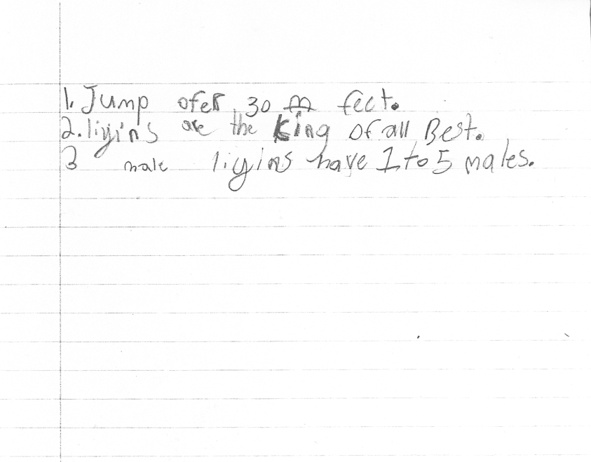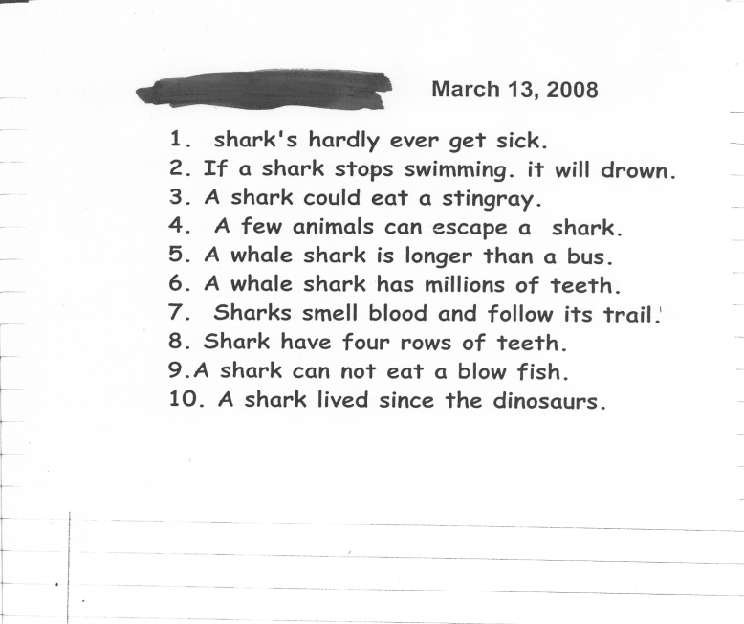

Without a Text Reader
(45 minutes to complete)

With a Text Reader
(15 minutes to complete)

“Text to speech programming is an amazing tool for my son. Now he has a voice through story writing. His dysgraphia hindered all his creativity. He was stuck, frustrated and depressed. Now, using Kurzweil in school and home, my son looks forward to writing and sharing his written work.”
-Parent
The O’Hearn

Text Readers in the Classroom

The Kurzweil text reader is shown to have a positive impact for students both quantitatively and qualitatively. To analyze its specific quantitative impact, our research team used two reading measures, the Developmental Reading Assessment (DRA) and the Fountas and Pinell Reading Level. We gathered assessment results for each of the students with one of the aforementioned disabilities both with and without the use of the text reader accommodation. We found that across the board, students were able to read at higher levels when using the accommodation. According to DRA scores, students performed 4-10 levels better with the accommodation, which equated to 1-1.5 grade levels better, and leapt one to four levels on the Fountas and Pinell measure.

Quantitative Impact

Qualitative Impact

Implementation: Technical & Adaptive
Technical Implementation:
Technical implementation of this accommodation consists of four major areas: technology, training, funding and capacity. When considering the technological requirements for implementation of a text reader, one must take into account the infrastructure, software, and hardware that are currently available and subsequently needed. For infrastructure, one must consider computer capacity. Most text readers require computers with an operating system of Windows 2000 or higher, processor speeds of 700 MHz or faster and at least 256 mb of free memory space. In the case of the O’Hearn, computers were initially too old to support Kurzweil’s text reader technology. Therefore, their first step was to purchase new computers and/or upgrade their older models. Since Kurzweil had the function to scan books, the O’Hearn also had to purchase scanners. They currently have six scanners throughout the school. Additionally, when considering which software to purchase it is advisable to choose a program with word prediction capabilities. The O’Hearn has chosen to use the Kurzweil program but other text readers such as E-Reader or IntelliTalk are also available. However, Kurzweil is currently the only text reader approved by the Massachusetts Department of Education for use on the MCAS.
In order to take full advantage of the text reader technology faculty, staff, parents and students must be properly trained to use it. At the O’Hearn, certain teachers felt more comfortable with new technology and were more computer savvy. As such, they were targeted first for training. The teachers were trained as part of their required in-school professional development. Due to this training, the school created a teacher identified support team in order to help teachers who needed assistance. The school also established a technical support liaison with Kurzweil so that faculty with questions could quickly call or email the company for help. To address student capabilities, all children engaged in some level of training during their normally scheduled work groups. Finally, a small group of parents were trained by the Kurzweil staff to use text readers at home. These parents then became parent trainers. They established a program using the “train the trainer” model whereby the parent trainers went into the homes of families who required the accommodation. They installed the
O’Hearn has accessed each of these funding

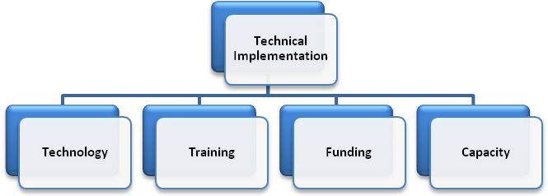
software on home computers and trained families on how to use the technology. Moreover, the O’Hearn further helped families who did not already have personal computers acquire this resource.
Funding is the third technical component that must be addressed. A text reader costs approximately $2,700 for a Windows learning lab pack. This consists of one scanner and five computer stations. However, text readers can also be purchased on a flash drive. A portable USB text reader costs approximately $900 and allows the student mobility. The text reader can now travel and be used on multiple computers. Aside from portability convenience, this is also a less expensive approach as compared to software. Furthermore, USB text readers increase the capacity for schools to implement various principles of universal design learning. In the case where a school cannot implement text readers in all classrooms, a flash drive allows sites to prioritize this accommodation for students who need it most. Moreover, there are many funding sources to pay for a text reader. A school may use special education funding or Title I funding. It can also apply for grants, solicit private funders, or hold fundraisers. The O’Hearn has accessed each of these funding sources to pay for their text reader technology, including Easter Seals grants.
Finally, it is important to address capacity; what the school currently has and where it needs to expand. In order to implement text reader technology into every classroom, the O’Hearn had to build capacity in its staff. The school has designated one teacher to serve as a full time Kurzweil coach. This teacher receives an additional stipend of $2,000 a year to help support and troubleshoot any problems that may occur. Also, the O’Hearn has assigned paraprofessionals to scan books for one period a week

move from “using a text-reader is not real reading” to the belief that reading is the act of making meaning from text, not simply pulling words from the page. Other shifts include the new belief that students will be more engaged in reading from all sources if they understand its purpose and that the technology is a tool which supports learning because everyone learns differently.
The O’Hearn has successfully navigated the adaptive component of implementation. Dr. Henderson employed three major strategies: acting as champion, networking, and normalizing. Each of these approaches required that he leverage the political and human resource frames (Bolman and Deal, 2003). First, he championed the needs of students with disabilities at all levels of outside organizations including with superintendents, CEOs, parents, teachers and legislators. He shared inspiring stories of students’ successes with text readers and was quick to give specific, genuine praise to those who were flourishing with the technology. He highlighted increased student achievement data, higher levels of student self-efficacy and reduced behavior referrals as a direct result of heightened engagement in learning. His stories were exceptionally powerful because he purposefully included the names of students and teachers as well as cited direct quotes from users or shared hard data. Throughout this process, his message was always consistent, clear and focused. Text readers work. Additionally, Dr. Henderson invited skeptics into the O’Hearn to view the text readers in action. This approach has proven to be an excellent strategy to bring about adaptive change. When skeptics see how students respond to text readers, combined with stories of other current and implications for future success, they often begin to shift their own beliefs.
Another way to bring about adaptive change is networking within the organization as well as with external partners. Internal networking includes identifying emerging teacher leaders and connecting them with similar leaders inside the school. This is particularly effective when teacher connections span across grade levels or content areas. By creating cohorts of supportive teacher leaders, they are able to exert their collective influence over their peers and reach teachers who otherwise might be reluctant to use text readers. The same holds true for external partners. Dr. Henderson’s connection with Kurzweil enabled text readers to be installed with technical support. His

in an effort to develop a robust digital library. Some students were also involved in the scanning process. Their library now boasts books in both digital and print format for use by teachers and students. Lastly, Dr. Henderson forged a partnership with representatives from Kurzweil. He agreed to allow Kurzweil to pilot a program at the school and conduct research on program implementation at the elementary level. In return, Kurzweil agreed to offer trouble shooting support and to help the O’Hearn with any technological problems. By effectively utilizing human capital, the O’Hearn was able to increase their capacity to implement text readers more efficiently and on a larger scale. In a discussion about capacity, Dr. Henderson shared, “I think everybody sees the need, and they have the commitment. I think that is important. I think the kids need to use it regularly. If they’re going to read a book thoroughly, they can’t just use Kurzweil on Tuesdays and Wednesdays. It’s got to be as available as a book” (Personal Communication, April, 17, 2008). Successfully addressing each of these technical components of facilitation has allowed text reader and digital books to be a readily available resource for students at the O’Hearn.

Adaptive:
Adaptive change requires a shift in one’s beliefs, norms, values, or assumptions. It facilitates change in mindset. When beginning to implement text readers in a school one may encounter opposing assumptions that challenge the validity of the technology. Some may feel that using a text reader is not “real reading” because a child does not lift words from the page. Others challenge the text reader accommodation because they feel that it will eventually discourage students from trying to read from print books or that they will feel stigmatized by using the accommodation rather than traditional text. There is even skepticism over the reliability of the technology and whether it takes away the “feeling” of reading. Each of these beliefs must be addressed before text readers are implemented in the school. Acquiring the physical infrastructure to implement text readers will only be successful if an accepting cultural foundation has been laid. Creating this foundation may involve actively working to change long-standing norms, values or assumptions which challenge the new technology. An example of an appropriate mindset shift includes the move from “using a text-reader is not real reading” to the belief that reading is the act of making-meaning from text, not simply pulling words from the page. Other shifts include the new belief that students will be more engaged in reading from all sources if they understand its purpose and that the technology is a tool which supports learning because everyone learns differently.

connection with the community allowed him to leverage parent leaders to become parent teachers. His networking created a strong and supportive foundation for text readers to not only be implemented but to flourish as well.
A third way to foster adaptive change is to normalize concerns. For example, many teachers may become easily frustrated learning new technology. To counter these feelings, it is helpful to have other teacher leaders share their experiences and reflect about their own personal struggles with the accommodation. Sharing, or normalizing, frustrations and concerns can smooth the change process and leave the teacher feeling less isolated. Furthermore, sharing research which suggests that it may take as long as seven weeks before teachers and students see gains in achievement can help assuage teacher concerns about impact and effectiveness. In general, when one knows the process may take long, one is more patient and even perhaps even more persistent.
If we are to normalize that assumption that everyone learns differently, then classroom practice must reflect those beliefs. This is a basic tenet of universal design. Rose and Meyer (2006) state “…students who are ‘on the margins,’ for whom current curricula are patently ineffective, can actually lead the way to true reform because they help us understand the weaknesses in our educational system and curricula that impede teaching and learning for all” (p.13-14). Teaching all students how to use the software and designing instruction so that all students have access to the text readers eliminates the stigma learning disabled students may feel. Consistently using text readers throughout the lesson upholds the norm that we all learn differently. As a result, technology becomes the standard and not the exception.

“There’s no question that there’s a lot of great policies and laws in education, but the resources to implement them are restricted so it’s our jobs as educators to do what we can to help, to advocate, to hustle, to fund raise but most of our energy still needs to go to teaching” Dr. Henderson’s quote exemplifies the idea that implementing inclusive practices in a school is not an easy or seamless process. Indeed, “this is rocket science” (Hehir, 2008). It takes careful planning, dedication, commitment and strong social capital. Implementing a text reader accommodation is just one component of effective inclusion practices. in the general education classroom thus raising their self esteem and minimizing the impact of their disability.

Using this type of technology allows students with disabilities to interact with the curriculum at a deeper level. It also maximizes their opportunity to participate
We recognize four concrete steps for bringing text readers into a school; (1) identify student need, (2) choose a text reader, (3) plan for implementation and finally (4) develop a supportive culture. First, identify student need. While text readers have shown to have a host of positive effects, it must be an appropriate accommodation for the student. Using a text reader must be purposeful and meet the student’s specific need. Only if it addresses the student’s disability should it be included in the child’s IEP regardless of whether the school has the technology prior to including it in a student’s IEP. Once a need for text readers has been identified, the school must then choose the appropriate text reader for their students. The O’Hearn has chosen to use the Kurzweil text reader largely due to the fact that Kurzweil is the only text reader that is an approved accommodation on MCAS; but as presented earlier, there are several other options to choose from. Again, it is critically important to consider which text reader is most appropriate for students given their disability. Next, create a detailed plan for implementation. We have addressed many of the technical and adaptive components that must be considered before implementation can occur. Text readers are a large investment in time, money and resources for a school. It is important that factors such as infrastructure, funding, training, culture and capacity are thoroughly considered. Finally, develop a supporting culture. Access to education for students with disabilities has made enormous strides in the last three decades. However, inclusionary practices are still new and unfamiliar to many educators. As such, mindsets and assumptions about student capabilities and expectations may need to be shifted. This takes dedicated, collaborative and proactive teachers and administrators. This commitment reflects our original theory of action: if we provide teachers with the awareness, knowledge, and skill to implement the text reader accommodation in their schools, then we will ensure more students with various disabilities get access to print or content by way of minimizing the impact of their disability. And that by helping to change adults’ behaviors by way of introducing them to the accommodation, they will understand the potential impact and change their beliefs about the essential nature of this accommodation for maximizing students’ opportunity to participate in the general curriculum alongside their non-disabled peers.

Moving Forward In Your School:
The O’Hearn Elementary School
1669 Dorchester Ave.
Dorchester, MA 02122
Phone:
(617) 635-8725
E-mail:
ohearn@boston.k12.ma.us
This guide was created through a collaboration between teachers from the O’Hearn School and students from the Harvard Graduate School for Education
-2008
Sources:
Bolman, L., & Deal, T. (1997). Reframing Organizations. San Francisco: Jossey-Bass, pp. 3-17, 280-293, 294-317.

Deno, E. (1970). Cascade system of special education services. Exceptional Children, 37, 229-237.

Hehir, T. (2005). New Directions in Special Education: Eliminating Ableism in Policy and Practice. Cambridge, MA: Harvard Education Press.
Henderson, B. (2003). Inclusion at the O'Hearn.

Rose D. & Myer A. (2005). The Universally Designed Classroom: Accessible Curriculum and Digital Technologies. Cambridge MA.: Harvard Education Press.

Shaywitz, S. (2003). Overcoming Dyslexia: A New and Complete Science-Based Program for Reading Problems at Any Level. New York, Alfred A. Knopf.

